Step 1: Understand Recursion
Recursion is a technique where a method calls itself to solve a smaller version of the same problem.
Example:
factorial(5) = 5 * factorial(4)
A recursive function must have:
- Base Case – stops recursion.
- Recursive Case – calls itself with a smaller problem.

Step 2: Create a Recursive Method
Financial forecasting often uses:
$$Future Value=Present Value×(1+GrowthRate)^{n}$$
Using recursion:
futureValue(value, rate, years)
- value = current amount
- rate = annual growth rate
- years = number of years to forecast

Step 3: Implementation (Java)
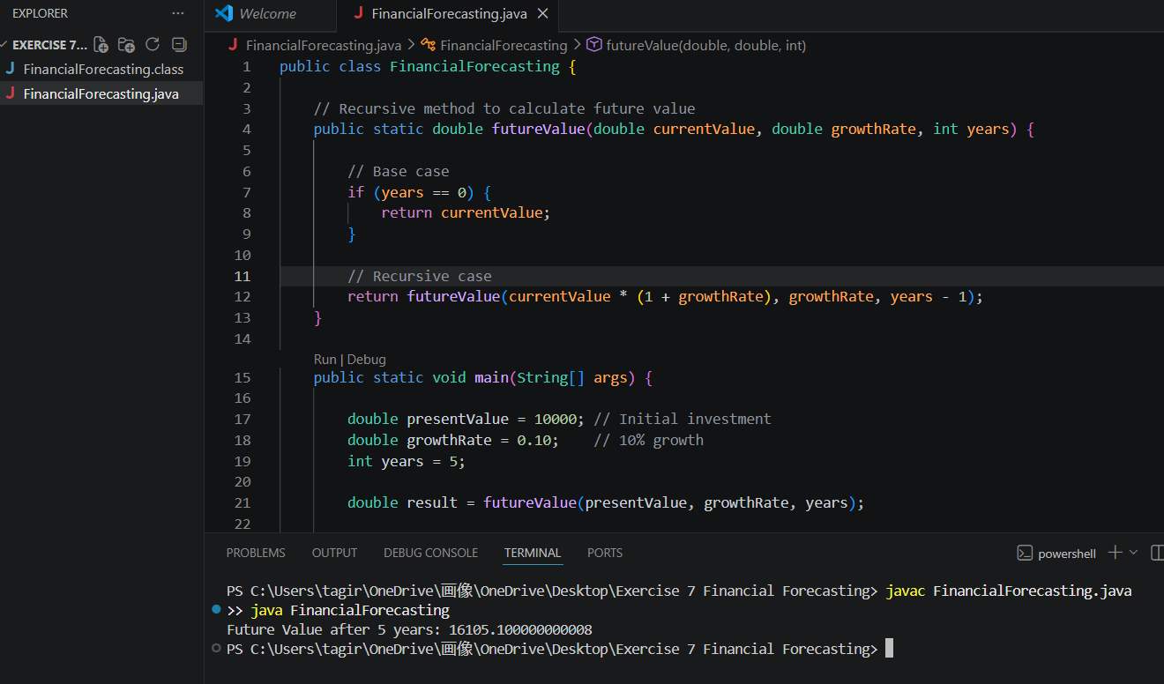
Step 4: Analysis
Time Complexity
For every year, the function makes one recursive call.
T(n) = T(n-1) + O(1)
Therefore:
Time Complexity = O(n)
where n is the number of years.
Space Complexity
The recursion stack stores one call per year.
Space Complexity = O(n)
Optimization
For large values of n, recursion can cause:
- Excessive memory usage
- Stack Overflow Error
Option 1: Iterative Solution
public static double futureValueIterative(double currentValue,
double growthRate,
int years) {
for (int i = 0; i < years; i++) {
currentValue *= (1 + growthRate);
}
return currentValue;
}
Time Complexity: O(n)
Space Complexity: O(1)
Option 2: Direct Formula
$$FV=PV(1+r)^{n}$$
double futureValue =
presentValue * Math.pow(1 + growthRate, years);
Time Complexity: O(1) (conceptually)
Space Complexity: O(1)

